Programming Exercise 1

**Java Fundamentals and Methods**

***Directions for completing and submitting the assignment:***

1. To complete the assignment, Use jGrasp or another IDE tool, to write and compile source code for the program. Your source code should be in right format:
   1. For source code, write your name, course number, section number and assignment number before your code in comments as shown as the following:

//*****************************************

// Name: First Last

// CSI 163-section#

// Programming Exercise 1

//*****************************************

* 1. Follow naming rules and conventions to name class, method, variable, and constant.
  2. Indent your code.
  3. Use proper whitespace.
  4. Write comments:
     1. MUST use documentation comments (start with /** and ends with */) before blocks of a class and a method. For each method, specify purposes, return types and parameters (if any) following the formats in the examples in the textbook, P273 (Code Listing 5-9) or PaintJobEstimator.java in Unit 1 Practice problems.
     2. Use other comment styles (/* … * or //) for other statements as needed.

1. Tips for programming:
   1. To avoid mismatching {}, create a right block using { } for the class and each method before you write detailed code.
   2. **Define** a method, and then **test** it in the main() method, **one by one**.
   3. To be easy debugging, compile your code line by line or block by block. Don’t finish the whole program and then test it.
2. Submission:

Submit your source code (**one .java** file, not .class file) in the drop box by 11:59pm on Tuesday, 3/31.

To submit your assignment in a drop box, on the page for the unit, click the assignment link, you will see the assignment submission page. On the page, click the button, “Submit Assignment” on the right panel, and then you see the drop box as shown below:

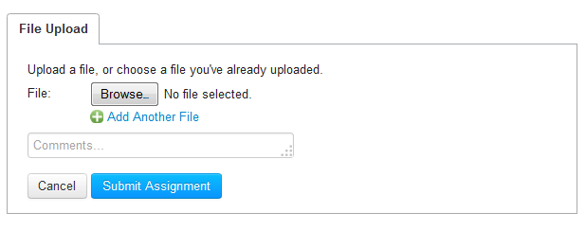

And you click the button, “Browse” to select you file. In the “Comments …” box, type your first name, last name and assignment number in this format: “first last – assignment #”, for example, “John Doe – Lab 1”.

Once you select your file and type information in the box, click the button, “Submit Assignment”, and then you are done.

***Lab Assignment (100 points):***

Write a program that asks the user to enter the radius of a circle, and calculates circle’s area, diameter, and circumference, and then display these calculation results.

The program should define the following methods, and then call them in the main() method:

* getRadius(): asks the user to enter a radius, and then returns the value. Use either the Scanner or the JOptionPane to get inputs from the keyboard.
* getArea(): returns the area of the circle.
* getDiameter(): returns the diameter of the circle.
* getCircumference(): returns the circumference of a circle.
* displayInfo(): display the circle’s radius, area, diameter, and circumference. Output for the floating points should be in the format of “#0.00”.

Notes:

1. To calculate the area and circumference, the value of π is used. Since the value is known, you declare a constant to store the value, 3.14, outside of all of methods (in global area), or use the constant pre-defined in the Math class – Math.PI.
2. **Please notice that some of the methods need parameter(s)**.
3. **If you do not create methods other than the main(), your assignment receives 0**.

***This assignment will be evaluated based on the following rubric:***

|  |  |  |  |
| --- | --- | --- | --- |
| **Category** | **Point Value** | **Break-Down** | **Points Earned** |
| **Code format and style** | 14 | Student’s information, naming rules and conventions, indentation, comments, and so on.  (Make sure you read ***Directions for completing and submitting the assignment.*** |  |
| **Declare constant(s) or use constant in Math class** | 4 |  |  |
| **Define methods** | 50 | Define methods – 10 for each |  |
| **Main()**  **method** | 32 | Declare variables - 12  Call methods - 20 |  |
| **Total** | 100 |  |  |